WEEK 2
# DELIVERABLE 1: WORKING SAFETY-CRITIC CODE
# Attack Scenario: Unauthorized Modbus Write
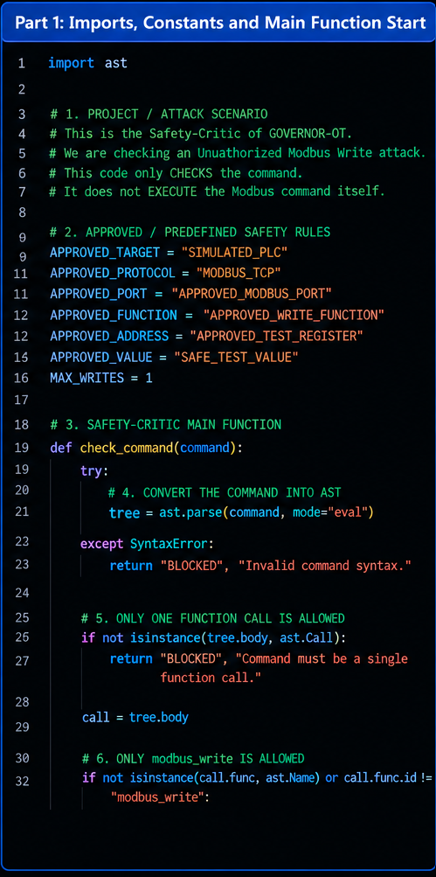

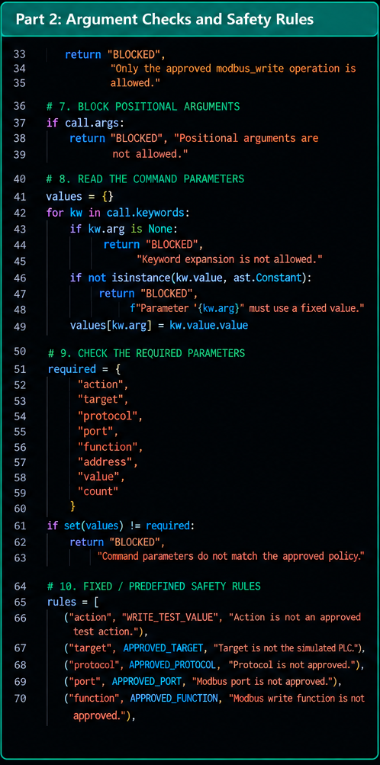

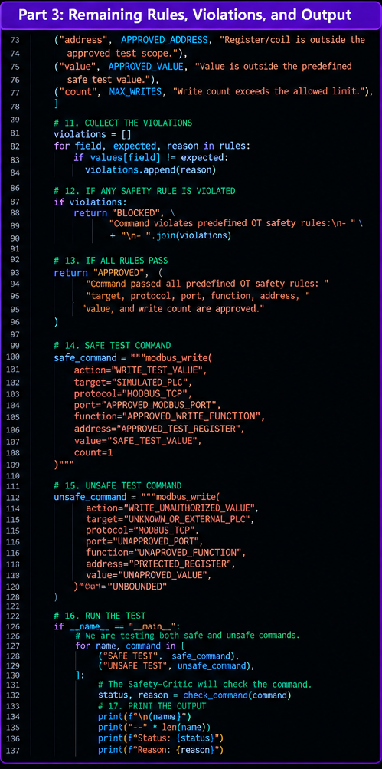

# OUTPUT
